**MY FAVOURITE FESTIVAL**

A festival is a special day or period in memory of a religious event. It is a celebration with its own activities, food, and ceremonies. It is a period of time where people joyfully spread the message of love and sharing to each other.

**Name**: Bhawya Manchanda

**Class**: 7

**School**: FAIPS/DPS, Kuwait

There are hundreds of festivals celebrated each year, the most popular being Holi, Diwali, Christmas, Eid, Thanksgiving, and Baisakhi, to name a few. Everyone has his/her favourite festival, and my favourite festival is Diwali, aka “*The Festival of Lights*.”

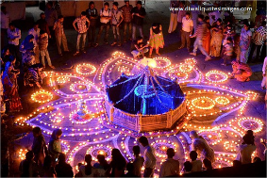**WHY IS DIWALI CELEBRATED?**

* Diwali is celebrated as the day Lord Rama returned to Ayodhya post a 14-year exile, accompanied by Sita, Lakshman and Hanuman.
* It is a symbol of a victory of good over evil and light over darkness, marked by Lord Rama and his accomplices returning to Ayodhya after defeating demon king Ravana’s army of evil.
* The residents of Ayodhya lighted the entire city with diyas and rangolis to commemorate his return, a tradition followed to this day.
* Some people also believe it to be the day when Goddess Lakshmi married Vishnu and some other consider it to be her birthday.

**WHEN IS IT CELEBRATED?**

* 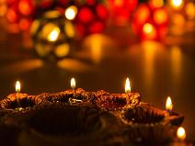Like other major festivals, the occurrence of Diwali depends on the Moon. However, it generally takes place at around mid-October to mid-November (the Kartik month in the Hindu calendar) during the new moon (अमावस्या).
* It is marked as a national holiday in 12 countries, including India and Nepal.

**HOW IS IT CELEBRATED?**

* Diwali stretches across five days:
* *Dhanteras,* the day when people buy utensils, ornaments etc. as a ritual two days before the new moon.
* *Chhoti Diwali* or *Naraka Chaturdasi,* the daydemon Narakasura was killed by Krishna*,* where people make rangolis and light diyas*.*
* *Badi Diwali* or *Lakshmi pooja,* the most important day of Diwali and the day of the new moon. People wear new clothes and visit their neighbours and relatives during the day. During the evening, a customary pooja of Lakshmi and Ganesh is held featuring all the members of the family. Houses are lavishly decorated with flowers, rangolis, diyas and artificial lights and crackers are burnt.
* *Govardhan Pooja,* the fourth day of Diwali, where people offer food to God. Lord Krishna is believed to have lifted the Govardhan hill to protect the village people from the wrath of Lord Indra, when he made it rain heavily for a very long time as a punishment.
* *Bhaiya Dooj,* the last day of Diwali, is a celebration between brother and sister, somewhat similar to रक्षाबंधन(Rakhi) *.* According to mythology, Lord Krishna visited his sister Subhadra on this day after destroying the Narakasura demon.

**THANK YOU!**